Prasar Srivastava  
22BCE10841  
AWS Solution Lab2

STEP1: OPEN THE AWS CONSOLE AND CLICK ON IAM DASHBOARD

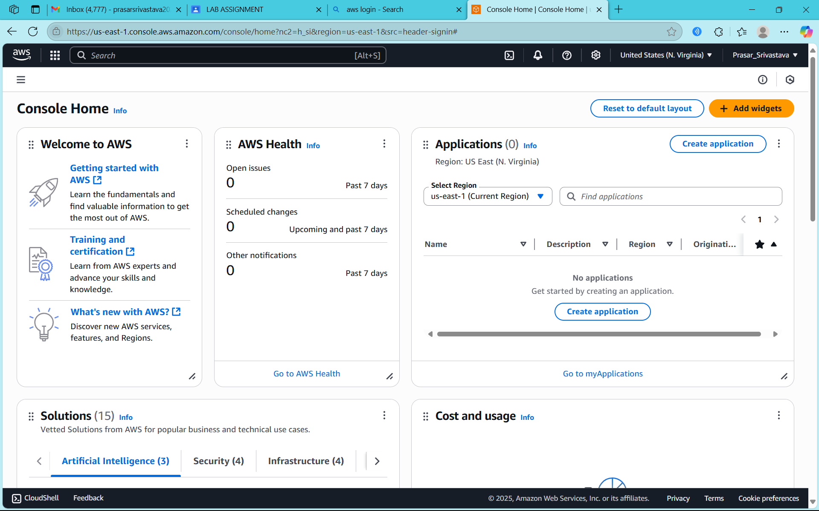

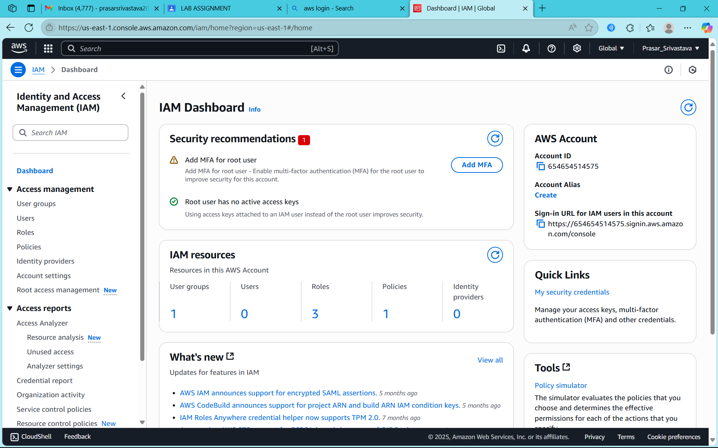

STEP2: CLICK ON USERS

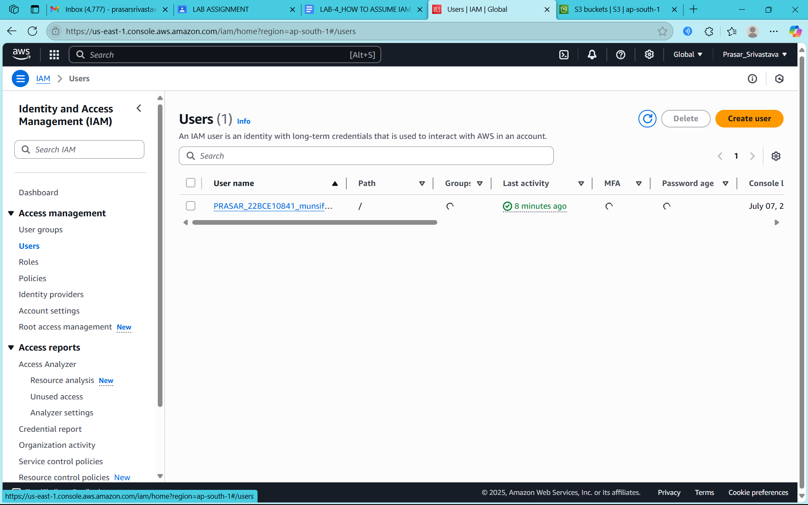

STEP2: CLICK ON IAM USER THAT YOU WANT TO ADD IN GROUP

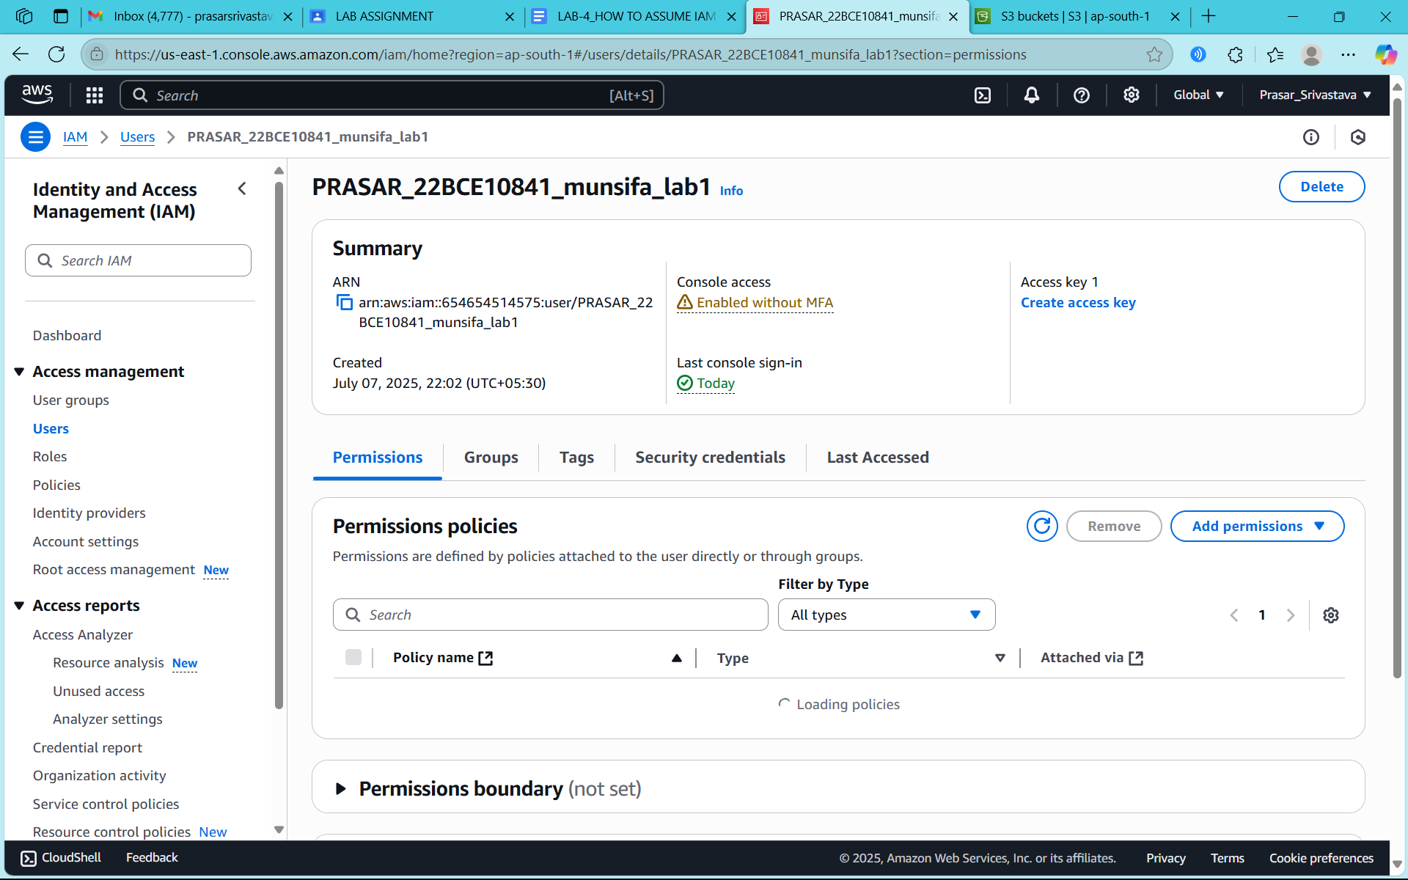

STEP3: SELECT ON THE POLICY THAT WAS EARLIER CREATED

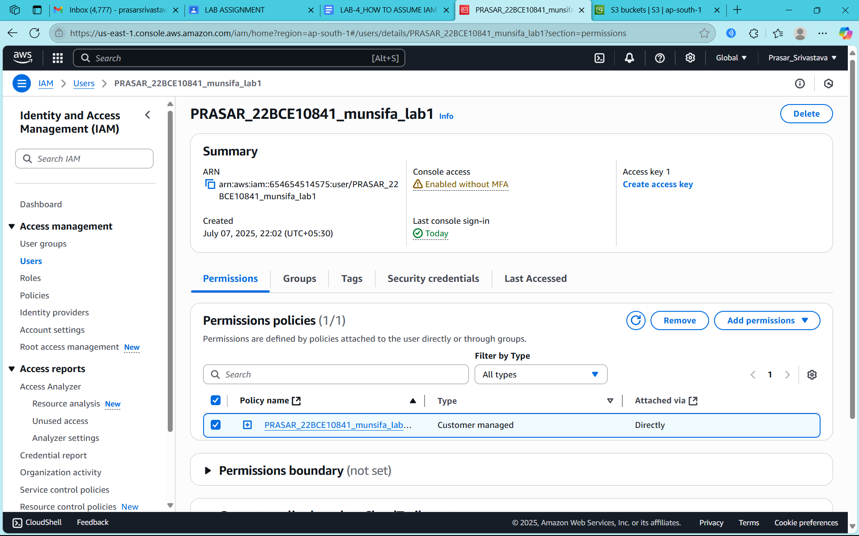

STEP4: CLICK ON REMOVE POLICY

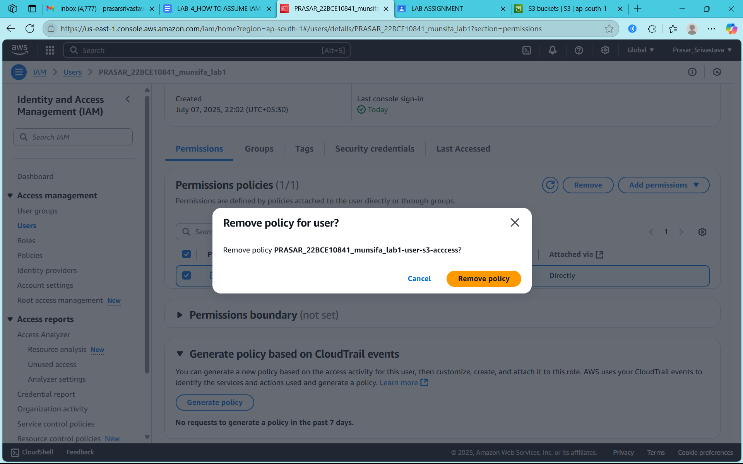

STEP5: YOUR POLICY IS REMOVED

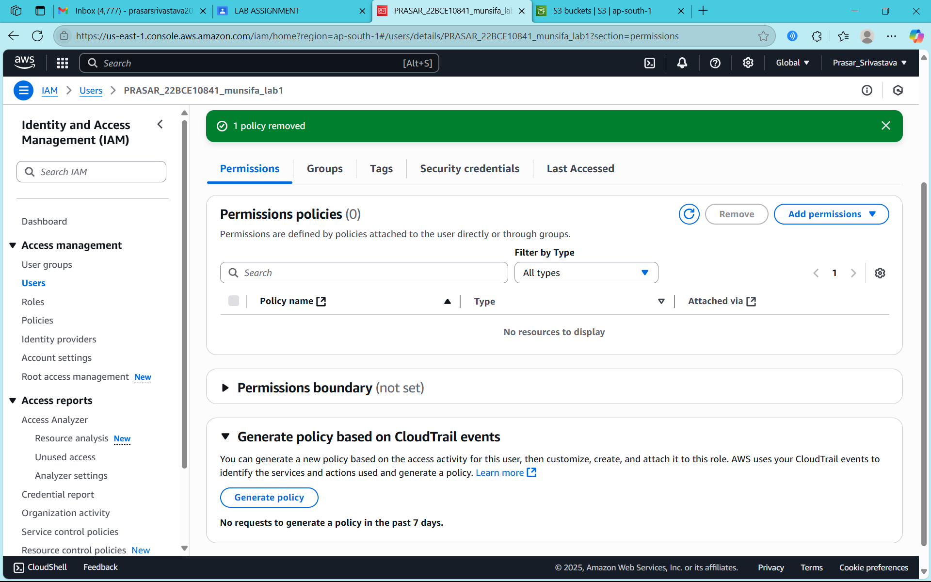

STEP6: CLICK ON USER GROUPS

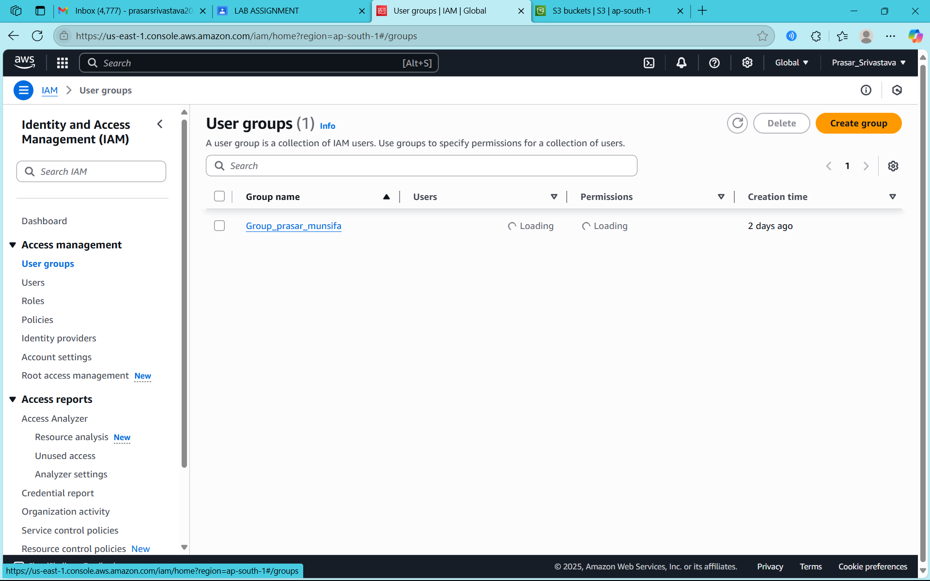

STEP7: CLICK ON CREATE GROUP

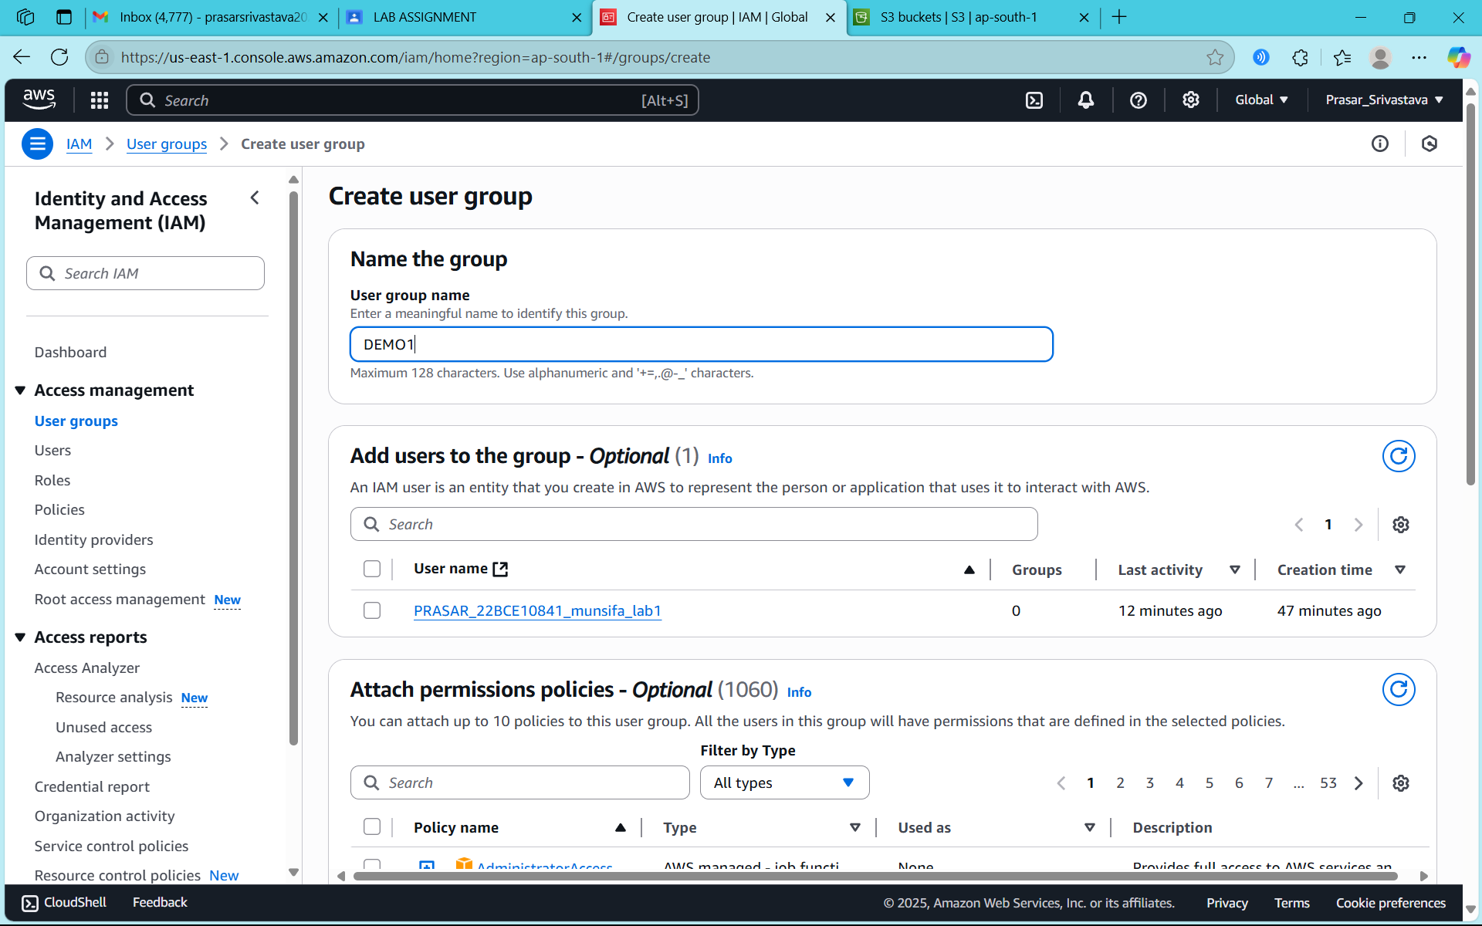

STEP8: TYPE THE NAME OF THE GROUP



STEP9: CLICK ON CREATE USER GROUP

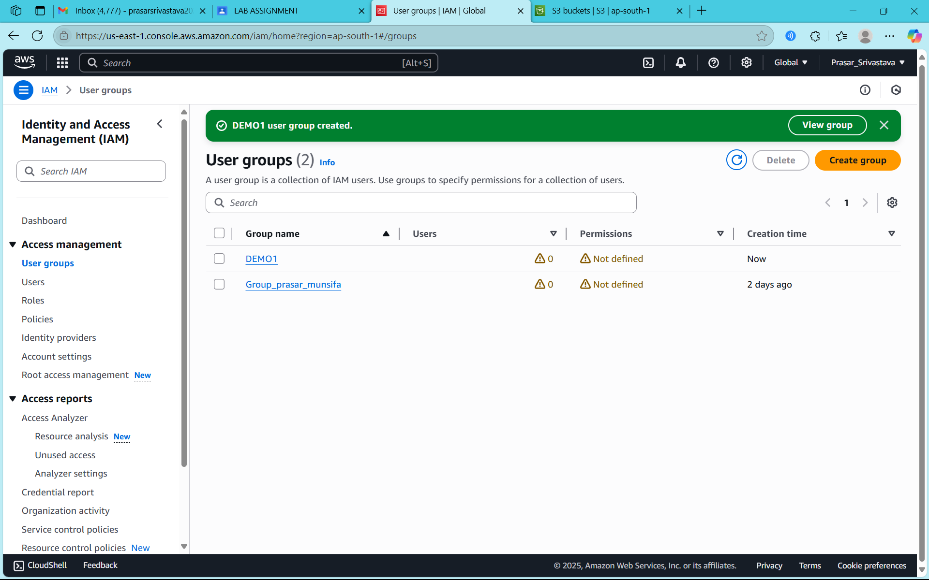

STEP10: DEMO1 GROUP CREATED



STEP11: CLICK ON DEMO1 GROUP

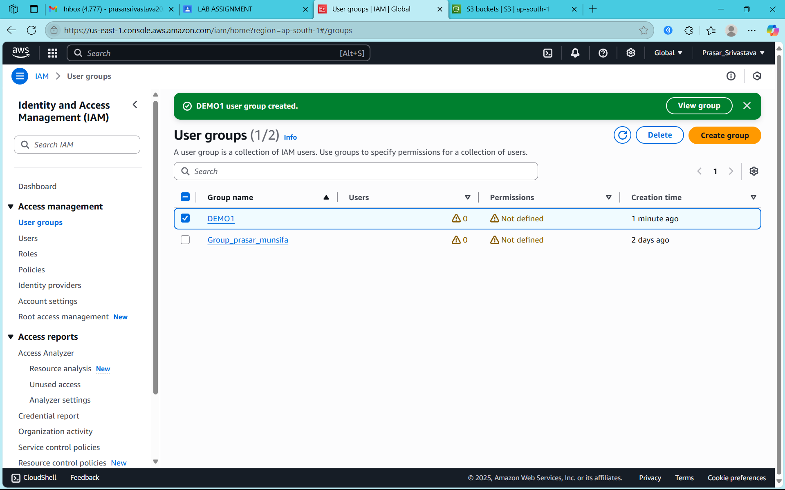

STEP12: CLICK ON ADD USER

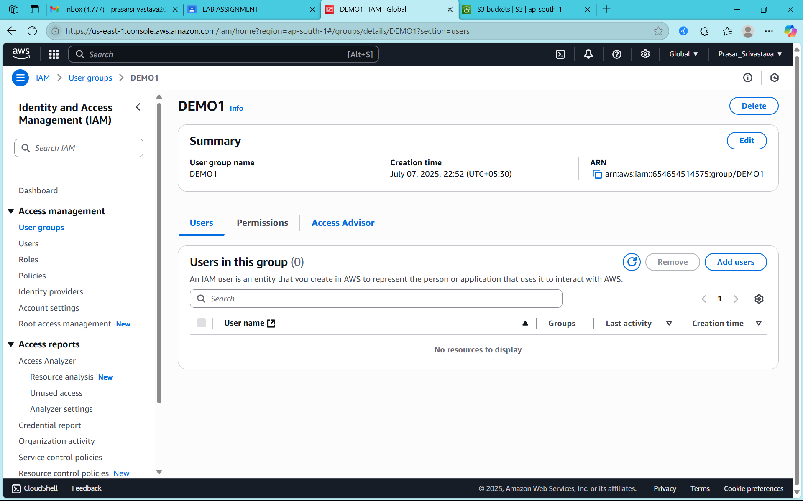

STEP13: SELECT THE USER YOU WANT TO ADD

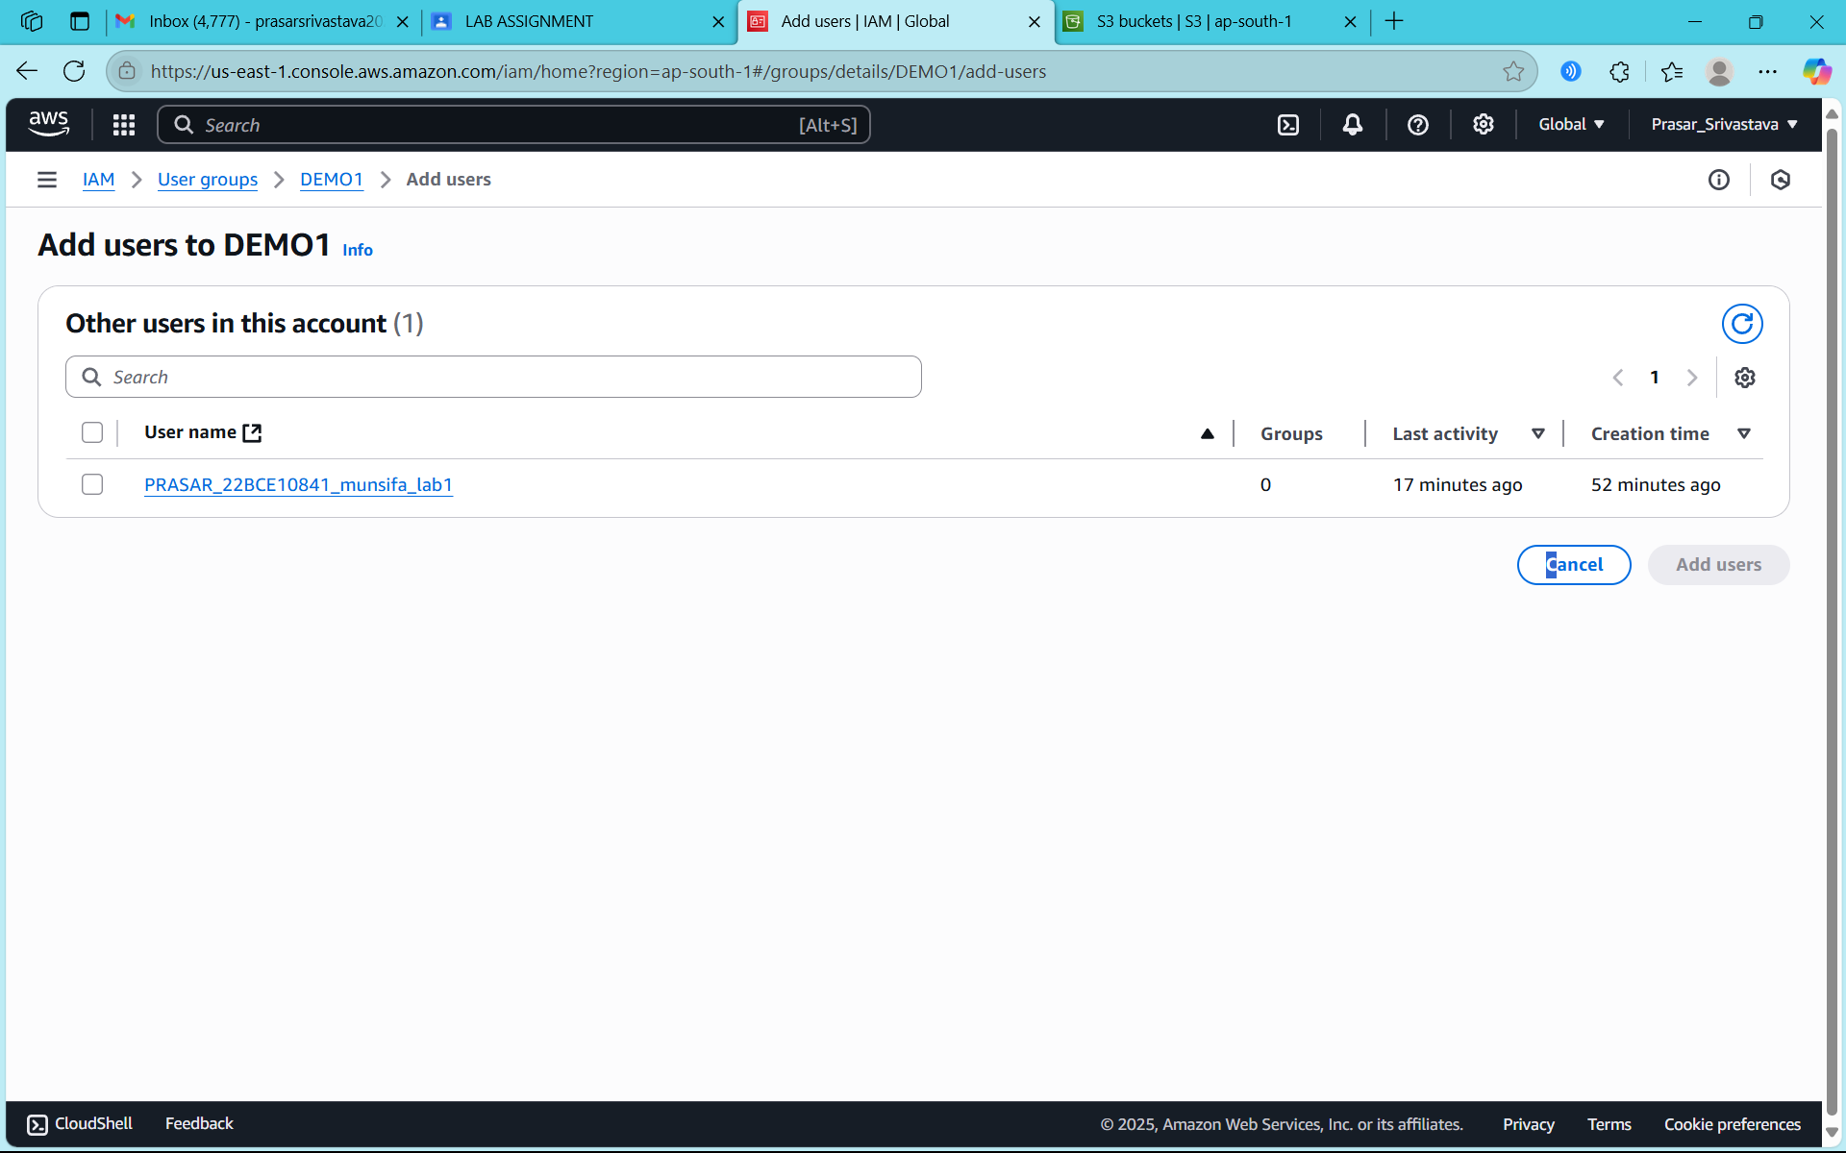

STEP14: CLICK ON ADD USER

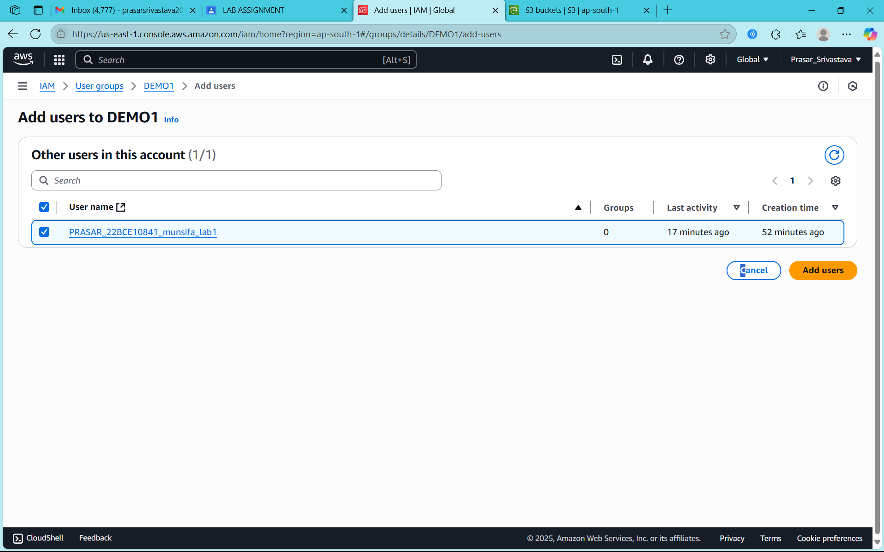

STEP15: USER IS ADDED TO THE GROUP

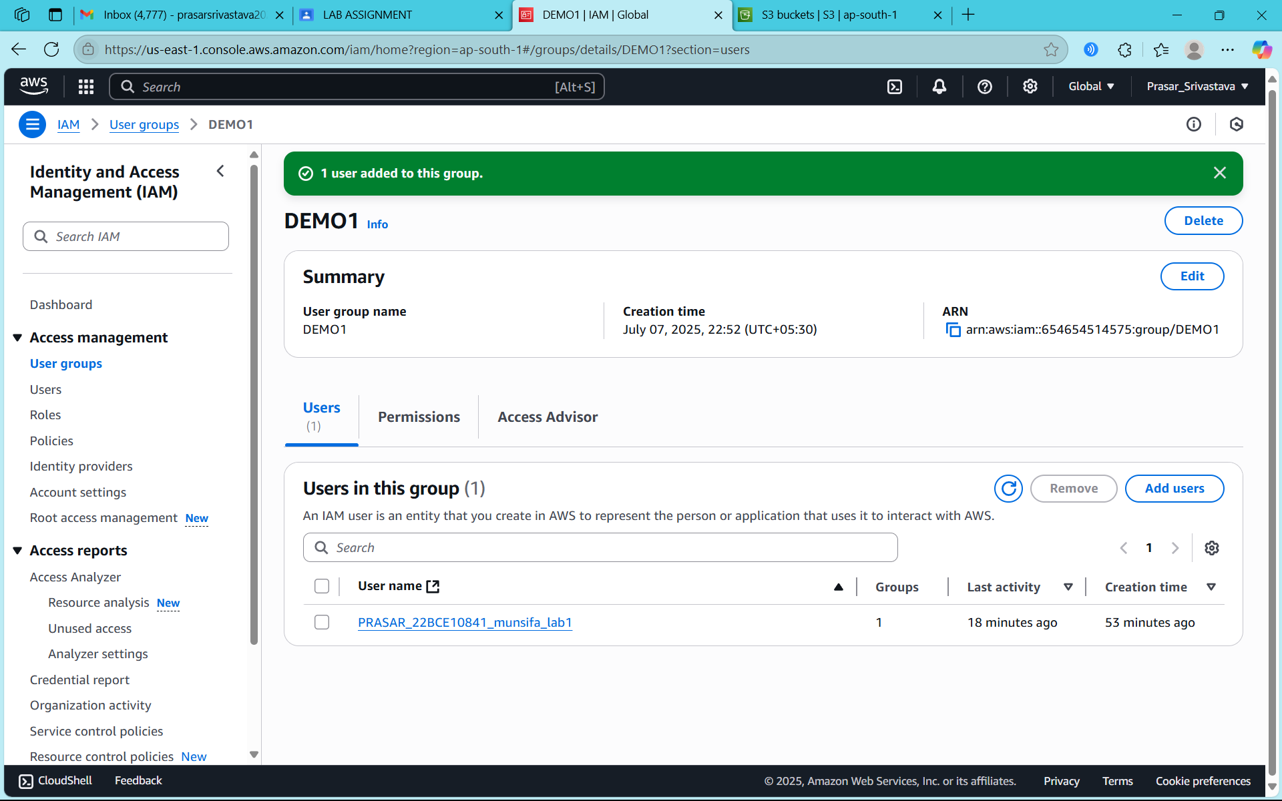

STEP16: CLICK ON THE DEMO1 GROUP

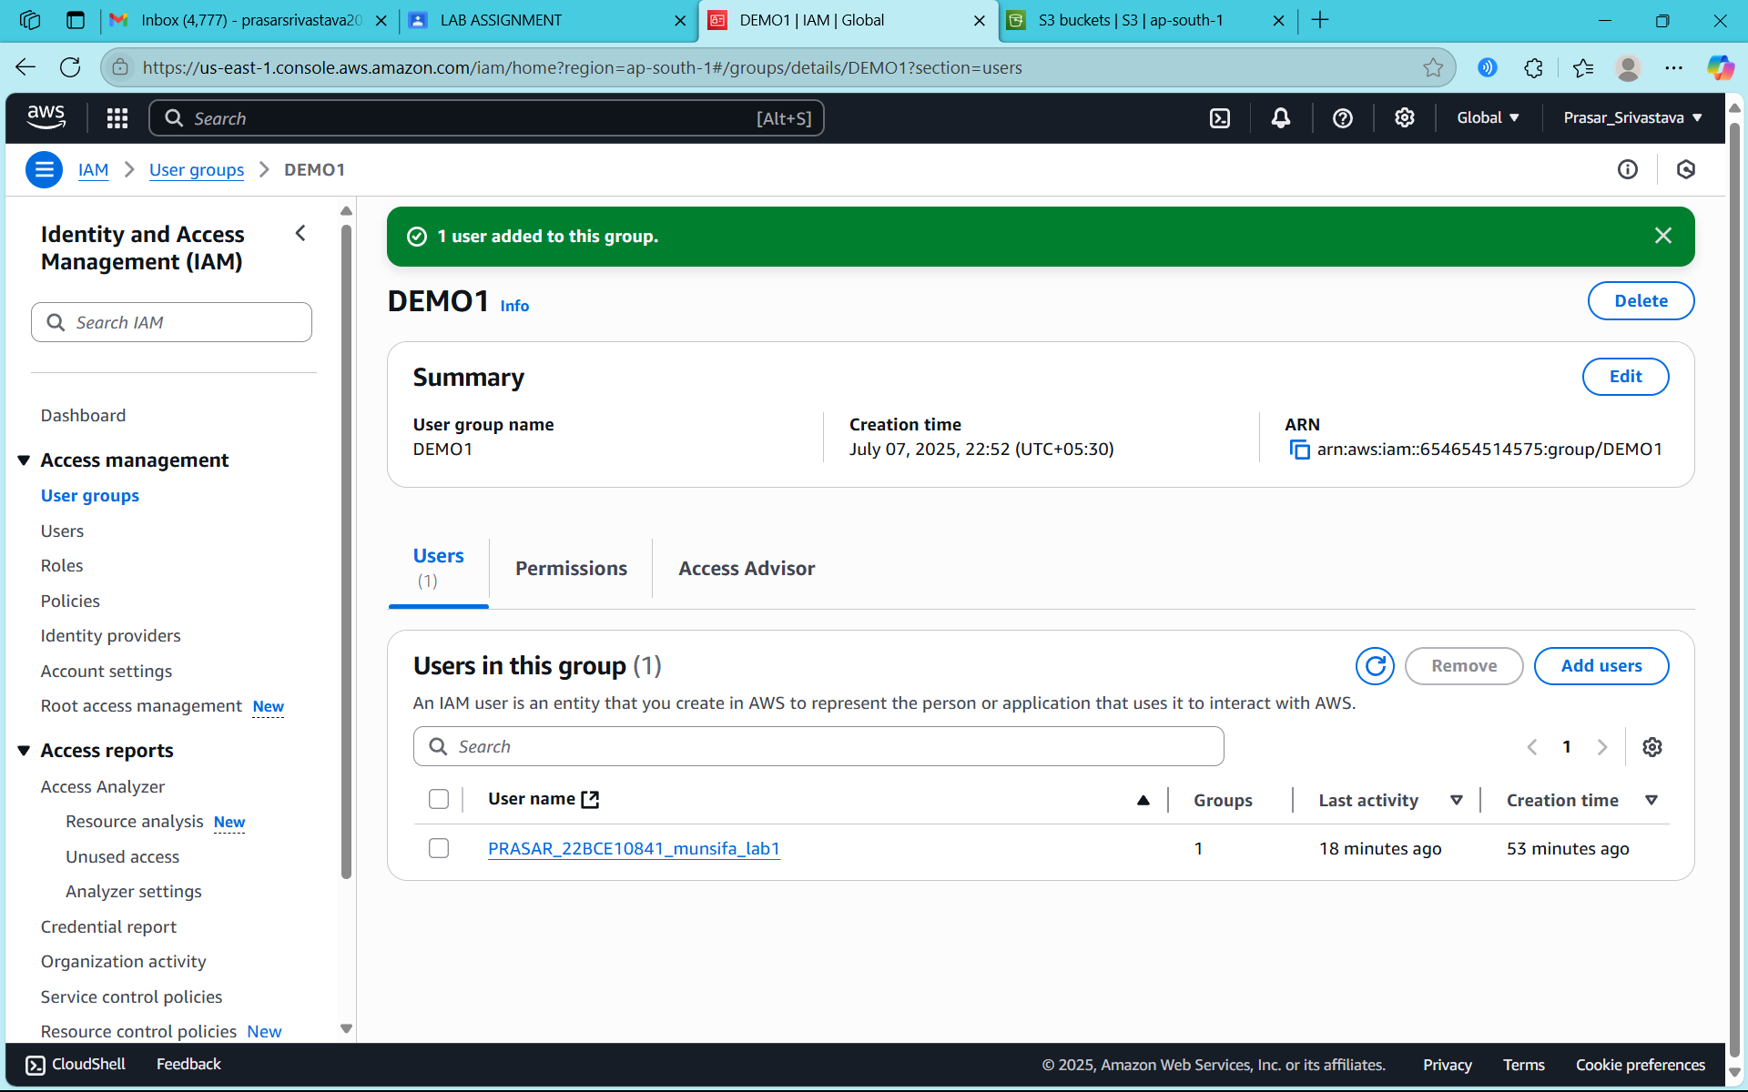

STEP17: CLICK ON ADD PERMISSIONS

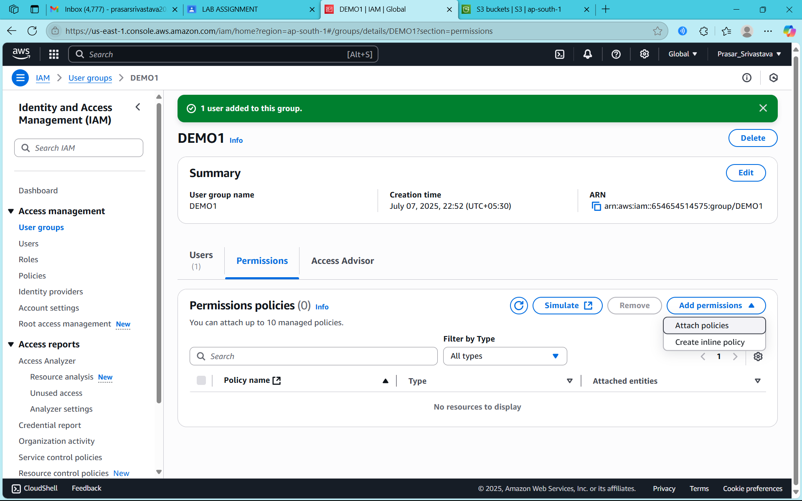

STEP18: SELECT THE POLICY THAT YOU HAVE CREATED

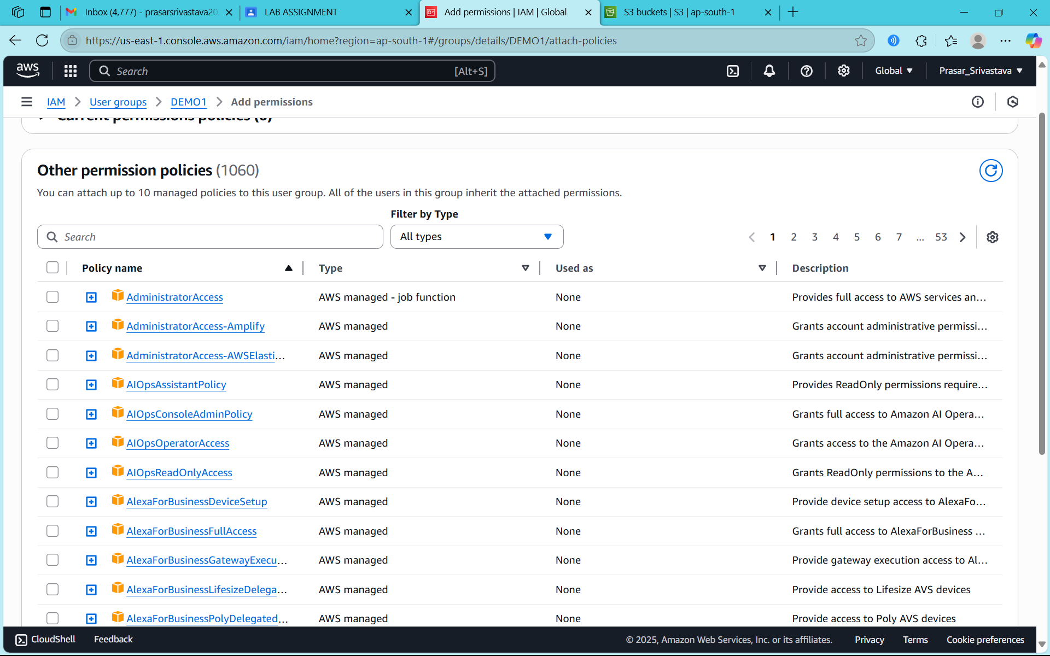

STEP19: CLICK ON ATTACH POLICIES

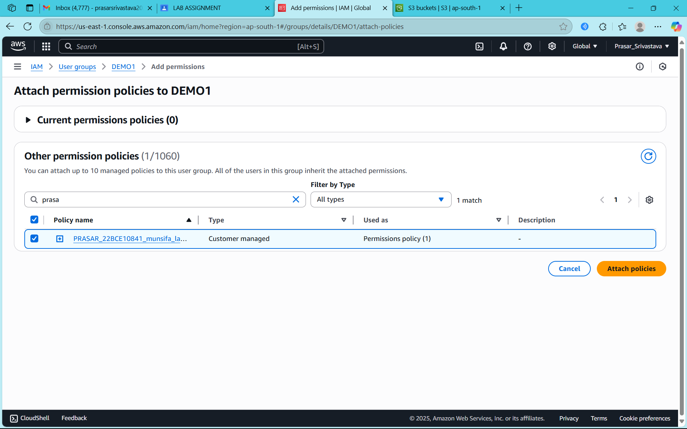

STEP20: POLICY IS ATTACHED TO THE GROUP

